**Download JDEV**

Go to below link

<https://www.oracle.com/dz/tools/downloads/jdeveloper-12c-downloads.html>

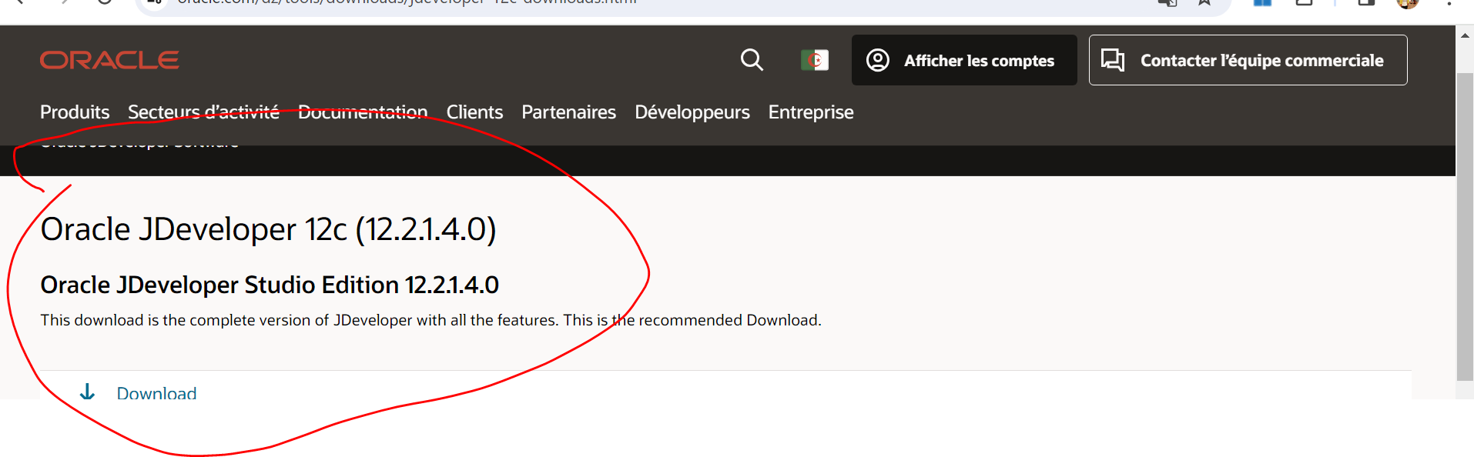

Login , if you have oracle account or signup

Select your windows version

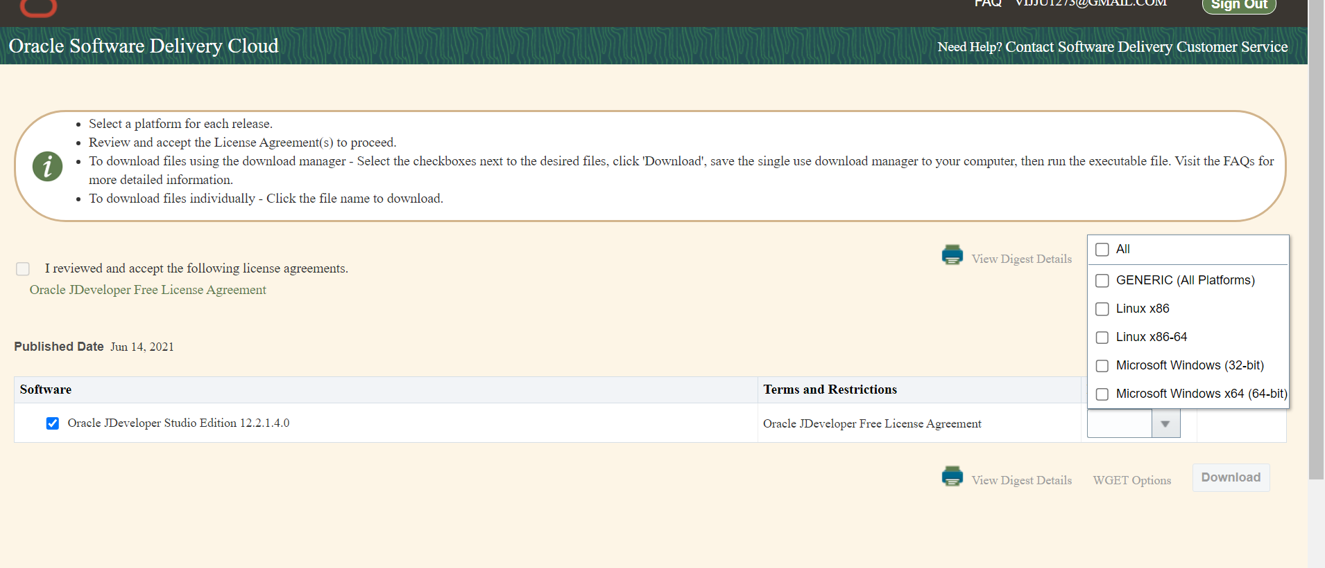

Select the check box

Click “Download”

